SUPPLEMENTARY INSTALLATION AND USAGE GUIDE
FOR THE PROCESS CONTROL APPLICATION

1. Input Requirements
The computer already has Python installed and can run version-check commands. The application source, the process log data file, and the supporting model files are ready in the same working folder.
If Graphviz is not available on the computer, it must also be installed because the application uses Graphviz to render the Petri Net model. Quickly check in CMD with the following commands:
python --version
pip --version
2. Components in the Application Source Package
Not every file in the source folder needs to be opened or handled directly. When the application starts, the main file automatically calls the remaining modules. The table below describes the role of the commonly used components in the source package.
Component | Role | Direct operation required | Notes
main.py | Main startup file of the application. | Yes | Use the command py main.py to open the application.
analysis_tab.py | Handles the interface and content of the Process Analysis tab. | No | Called automatically by main.py.
improvement_tab.py | Handles the interface and content of the Process Improvement tab. | No | Called automatically by main.py.
build_petri_net.py | Used to create or process the Petri Net model. | No | Used internally by the application.
main_screens.py | Manages the main screens of the application. | No | Called automatically when the program runs.
other_frames.py | Supporting interface frames. | No | Does not need to be opened separately.
plot_and_dataframe.py | Processes charts and tabular data. | No | Does not need to be opened separately.
install_required_libraries.bat | Helper file for automatic library installation. | Optional | If the .bat file is blocked, libraries can still be installed manually with pip.
run_app.bat | Helper file for automatic application startup. | Optional | If the .bat file is blocked, py main.py can still be used.
required_libraries.txt | List of required libraries. | No | For reference only.
README.txt | Short description or notes in the source package. | No | For reference only.
app_data/ | Folder containing data, .pnml files, .json files, or sample files. | Yes | Used when loading data or adding a model from file.
3. Install the Required Python Libraries
Open CMD in the application source folder, or open a normal CMD window and run the following command:
python -m pip install pandas matplotlib pm4py graphviz
Expected result: when the application runs, it no longer reports missing pandas, matplotlib, pm4py, or the Python graphviz package.
4. Install Graphviz to Display the Petri Net
This is the most important step in the installation and setup process. In the tested environment, the application could load data and display KPIs immediately, but it stopped when rendering the Petri Net model because the machine did not yet recognize the Graphviz dot command.
Download the Windows 64-bit EXE installer for Graphviz from the official website and install it with the default options. If the installer provides an option to add Graphviz to PATH, that option must be enabled. After the installation is complete, close all old CMD windows, open a new CMD window, and check again with the following command:
dot -V
Correct result: the screen displays a version line such as "dot - graphviz version ...".
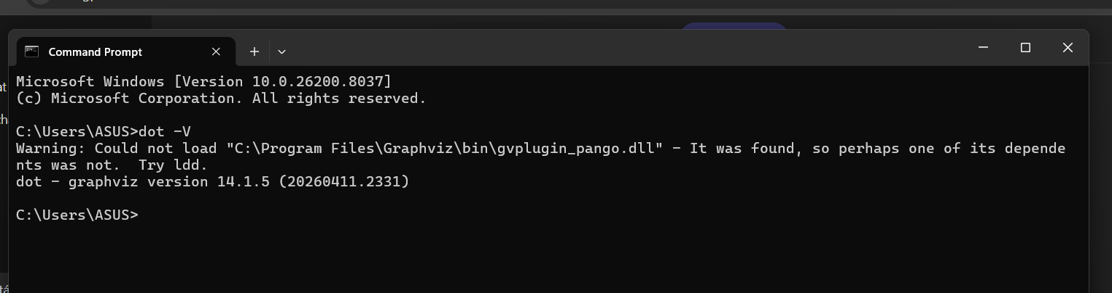
Figure 1. Graphviz verification after a successful installation.
5. Run the Application
Open CMD in the application source folder. Keep the CMD window open during the entire application session. Run the following command:
py main.py
Note: do not close CMD while the application is open, because closing CMD may terminate the application.
6. Load Data with New and Set Up the Process
On the first screen, select New. Choose the data file of the process to be analyzed. On the Process Setup screen, map the columns as follows:
Mapping item | Successfully used value
Case ID | case:concept:name
Activity | concept:name
Timestamp | time:timestamp
Time point type | end
Time unit | Day
Enter the process name and then click Continue.
7. Process Analysis Output
On the Process Analysis tab, the application displays: overall KPIs, the execution-time distribution histogram, the activity frequency chart, the cycle-time chart, and the Petri Net model on the full dataset.
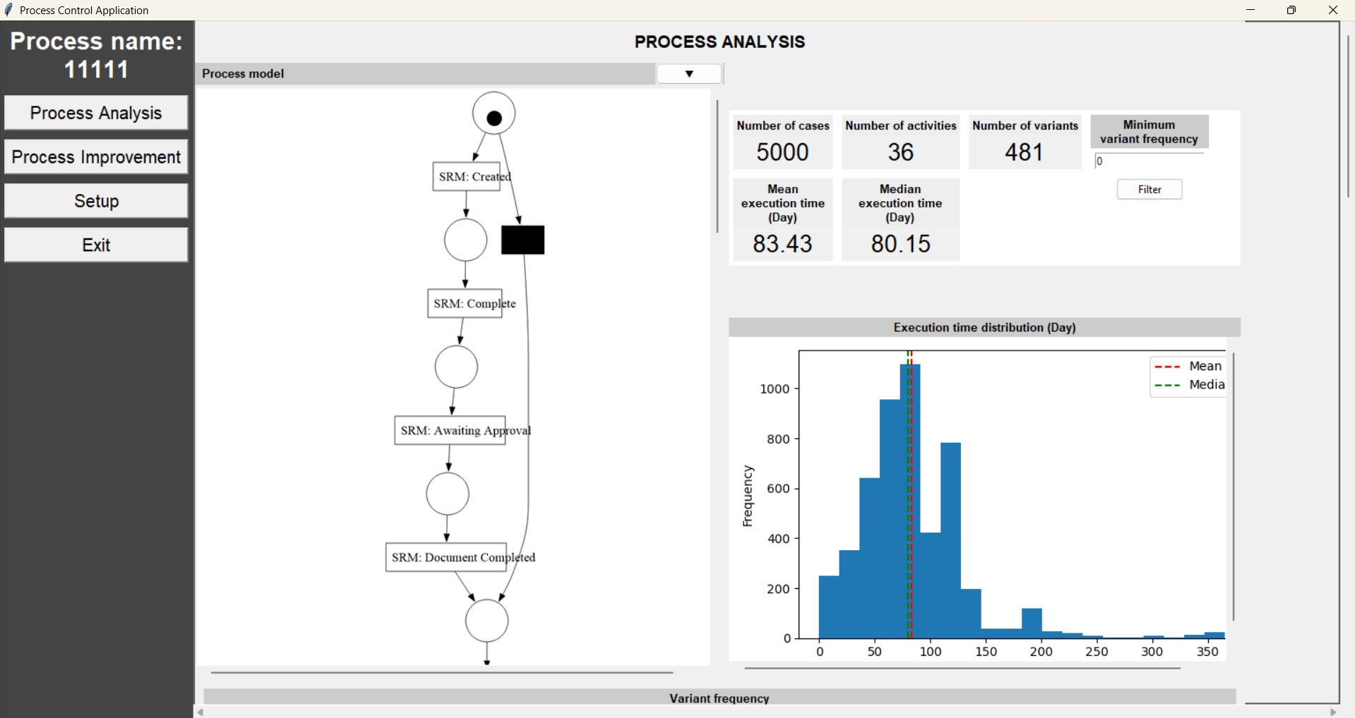
Figure 2. The Petri Net model was displayed successfully on the full dataset, together with the overall KPI block and the execution-time distribution chart.
When scrolling further down, the Process Analysis tab also shows the activity frequency chart and the top activities with the highest average cycle time. These charts can be used directly as evidence of the application output.
8. Process Improvement and Usage Notes
The Process Improvement tab is used by adding model files on both sides instead of creating a model manually from the beginning.
- Open the Process Improvement tab.
- In the Current process model area, click the small arrow and select Add model from file.
- Choose the first .pnml file.
- In the Improved process model area, repeat Add model from file and choose the second .pnml file.
- Scroll down to view the comparison metrics and the flows not appearing in the model.
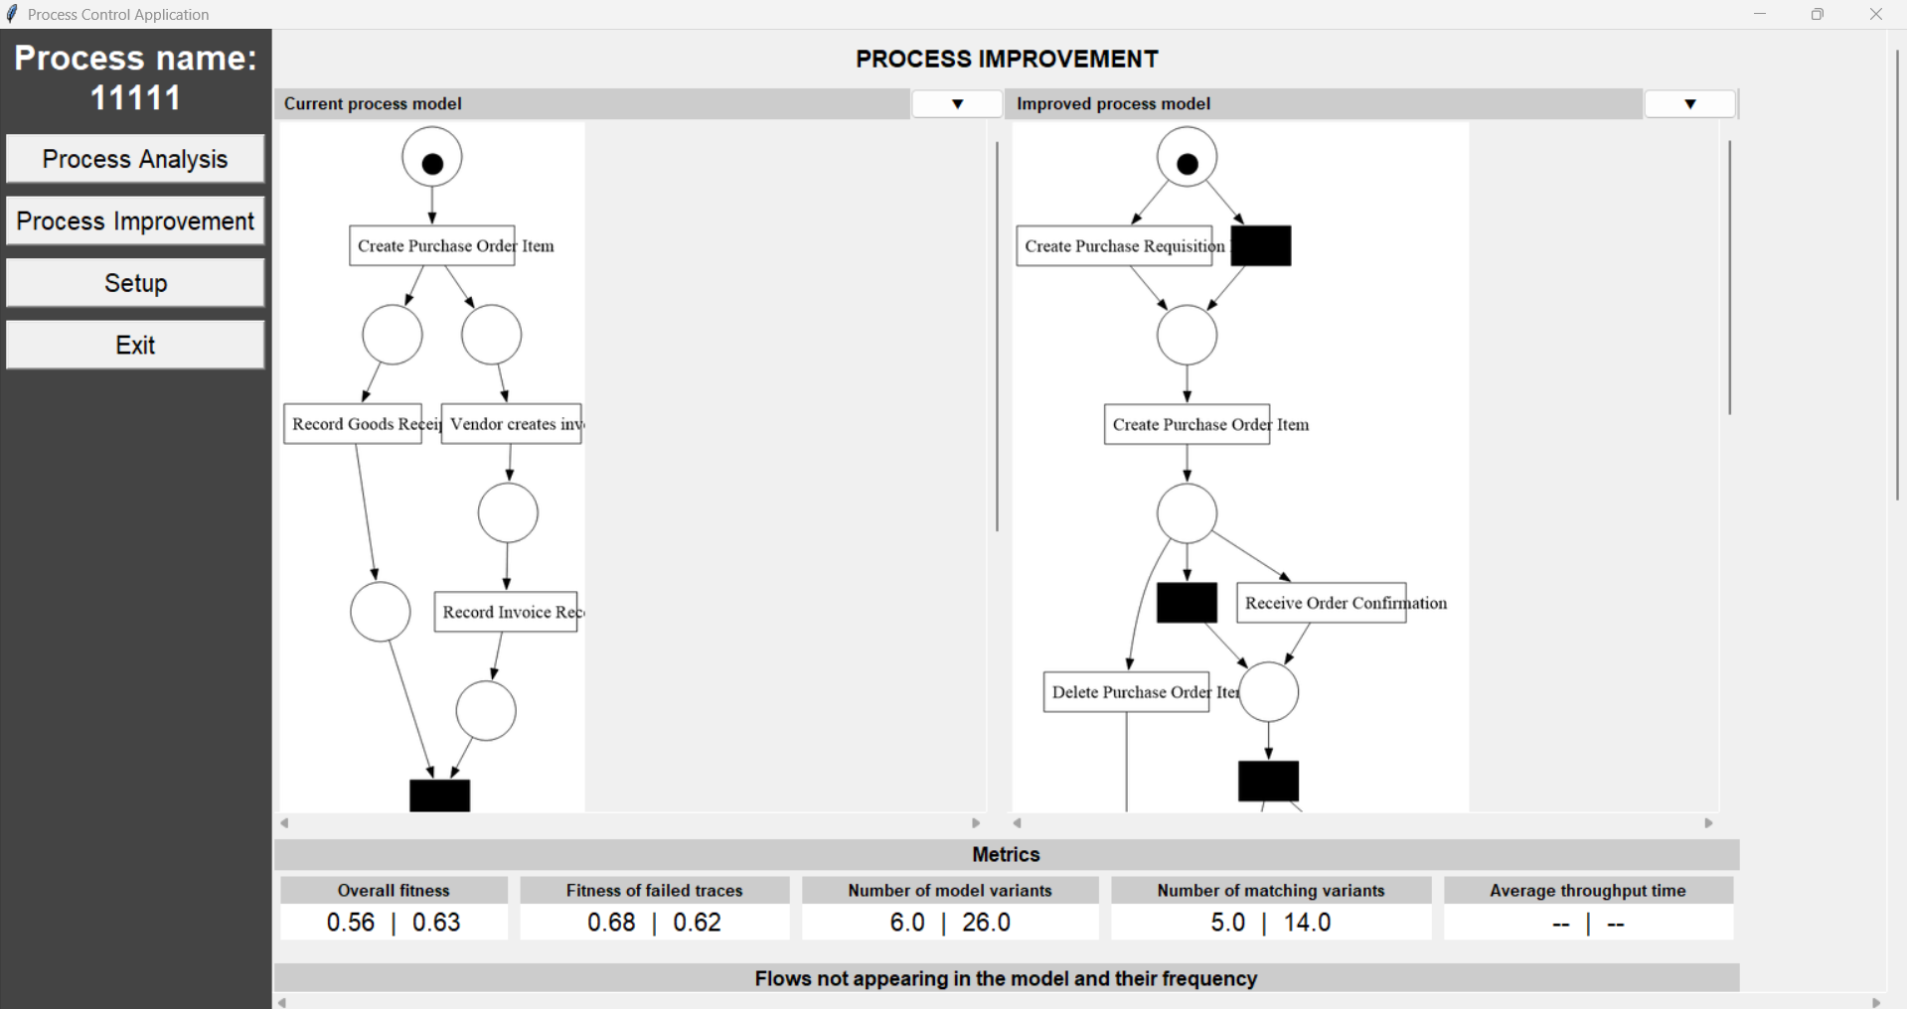
Figure 3. Two models were loaded in the Process Improvement tab, together with the comparison metrics and the table of flows not appearing in the model.
Note: In the current working configuration, the New function, process analysis, Petri Net display, the Process Improvement tab, and Save Setup can be used normally. The Open function from a .json file is not yet stable on the test machine and may produce a blank screen. Therefore, the most stable workflow at present is: New → select data → map columns → analyze → improve → save setup.

